- A chunky overshoot for UK services inflation in April has ended hopes of a June interest rate cut. Still, we expect the Monetary Policy Committee to stick to its message that rate cuts are coming soon if data fall roughly in line with its forecasts.
- The date for the UK general election (July 4) was announced on the same day the inflation data was published, so speaking restrictions mean MPC members have been unable to comment on the implications. We suspect that some of those who voted to hold rates in May initially expected to switch to voting for a cut in June, but now will not do so, producing a rerun of May's 7-2 vote.
- We expect the MPC to cut by 25bps in August and November. Though no longer our baseline, a third cut isn't out of the question if pay growth and inflation slow more quickly than anticipated, or an incoming Labour government front loads its tightening of fiscal policy.
The Bank of England used May's Monetary Policy Report and accompanying press conference to send a clear message that interest rate cuts are on the way provided the incoming data is supportive. But subsequently April's outturn for services inflation came in much higher than expected. This led financial markets to conclude the chances of a June rate cut are close to zero. We agree and expect the Monetary Policy Committee to vote 7-2 to keep Bank Rate at 5.25% at next week's meeting.
We highlighted the April data for services inflation and private sector regular pay growth as being key to when the MPC cuts rates. Both series have been identified as key measures of inflation persistence by the Committee. The April data for both promised to have outsized importance – the inflation print showed the impact of the annual increases for index-linked contracts and regulated prices, while the pay data incorporated the impact of the near-10% rise in the national living wage. In the event, the data sent conflicting messages.
Chart 1: The BoE's favoured measures of inflation persistence have sent mixed signals
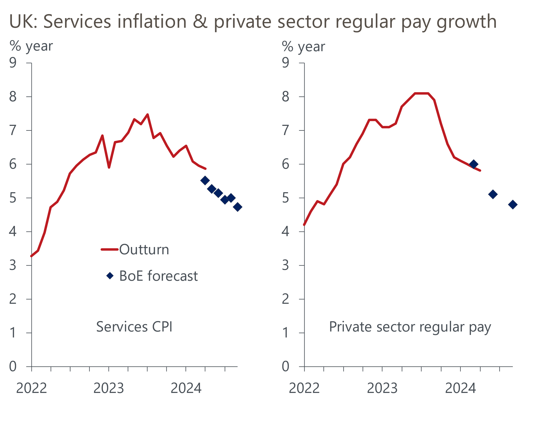
Sources: Haver Analytics, Bank of England Monetary Policy Report

Services inflation came in at 5.9%, 0.4ppts above the forecast made by the BoE staff in May's Monetary Policy Report (Chart 1). But headline (three month average of the annual rate) private sector regular pay growth continued to cool in April, dropping to 5.8% from 5.9% in March. The BoE only publishes quarterly forecasts for this series, but we think that given the scale of base effects that will come into play in May and June, the Q2 outturn is on track to come in at, or slightly below, the BoE's projection.
Projections by BoE staff have acted as an informal benchmark against which we can measure incoming data that matters to the MPC. With services inflation overshooting the BoE staff forecast by such a wide margin, we think it's unlikely that the MPC will contemplate cutting rates at the June meeting. Financial markets have certainly adopted that view – as of June 12, market pricing implied the probability of a June rate cut was just 13%.
Indeed, market pricing has shifted along the curve. Currently, markets expect a little over one 25bps rate cut before the end of the year, with the first cut only fully priced in November (Chart 2). After the May MPC meeting, markets had fully priced two 25bps cuts this year, while in the aftermath of the March meeting it was nearly three.
Chart 2: Markets have become progressively more hawkish in recent months
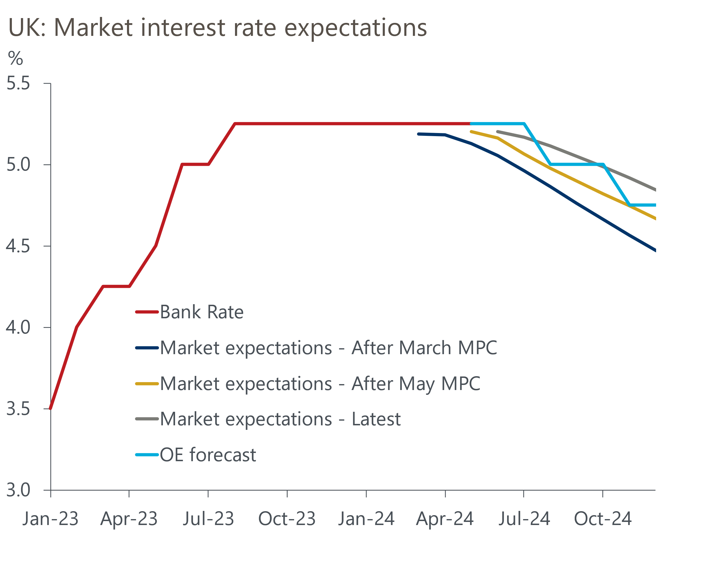
Sources: Oxford Economics, Haver Analytics
An added complication is that the date of the general election – July 4 – was announced on the day that the inflation data was published. The BoE cancels all speeches and public statements by its policymakers during general election campaigns, so none of the MPC members have been able to comment on the implications of the April inflation data (the few comments made by MPC members since May's meeting are summarised in Table 1).
The minutes of the June meeting will provide the first response to the inflation data and offer an opportunity for the MPC to guide markets ahead of the August meeting. The MPC could use the minutes in several ways to reinforce its dovish message and guide markets towards a likely late-summer rate cut.
The MPC could play down the importance of the overshoot for services inflation, arguing that April's outturn was heavily affected by the annual indexation and that this largely reflects past high inflation, so has limited implications for the timeframe that's important for monetary policy. In this respect the MPC could suggest that it's looking at how upcoming inflation figures (including the May data released just before the June meeting) measure up against the month-to-month changes in inflation implied by May's BoE staff forecasts, rather than against the forecasts for the y/y rate.
The MPC could also talk up the importance of labour market indicators, which have been more supportive of rate cuts. It's also possible that the MPC might try to move the focus away from the actual price data – a backward looking measure of inflation persistence – and adopt a more forward-looking approach, emphasising its forecast that inflation is likely to undershoot the target in two to three years' time without looser policy, arguing that loosening labour market conditions are evidence that disinflationary forces are strong.

We expect the BoE to cut Bank Rate by 25bps in August and November
In the aftermath of the April inflation release, we changed our BoE call to forecast the first rate cut would come in August, with another 25bps cut in November to put Bank Rate at 4.75% at year-end. For this scenario to play out, we would need the June minutes to show the MPC maintaining its dovish tone of recent meetings, and sending a clear message that April's inflation data only delayed the start of, not derailed, the rate cutting cycle.
Indeed, though no longer our baseline forecast, it's not out of the question that the MPC will still cut three times this year. If pay and inflation data slow more quickly than we anticipate, this could lead the MPC to start lowering rates in August and then cut at consecutive meetings, rather than only cutting in months when there is a Monetary Policy Report and accompanying press conference. Similarly, if an incoming Labour government decides to front-load its fiscal tightening, the MPC might opt to loosen monetary policy more quickly.
Table 1: Key comments by MPC members
Speaker and link | Date | Key takeaway
Bailey | 21-May | In a Q&A after a speech on unwinding the BoE's balance sheet, the Governor said he expected April's inflation figure to come in close to the 2% target and emphasised that the MPC had recently concluded that inflation persistence would be less than previously thought.
Broadbent | 20-May | In his final speech as a member of the MPC, Broadbent suggested Bank Rate could be cut in the summer if incoming data evolved in line with the MPC's forecasts.
Greene | 16-May | Greene argued that excess labour hoarding could help to explain why unemployment has stayed low despite weak output and wage growth has remained strong despite inflation expectations easing and the labour market loosening. She suggested April's pay data would be important, along with evidence on passthrough of wage costs to prices.
Pill | 14-May | The BoE's Chief Economist suggested "it wasn't unreasonable" to suggest that the MPC might be in a position to cut rates in the summer but cautioned that the labour market remains tight.
Sources: Financial Times, Bank of England, Reuters

